CFA 1000 Questions

Fixed Income
Question 1
- step-up note: interest rate increases
- sinking fund provision(条款): retire a specific principle of bond by year

Question 2
- (1+x%)⁴=(1+8/2%)²

Question 3
- Yield Curve: X:Time-to-maturity;Y: interest rate
- Duration:
  - X: interest rate; Y: bond price
  - Types(单一点变化）:
    - key rate duration: shape of the benchmark yield curve
    - modified duration: level of yield-to-maturity
- Slope of yield-to-worst curve
  - 两端差异

Question 4
- %P= -D*ΔP+1/2*Convexity*(ΔP)²

Question 5
- Interest Rate increases, the total return of bond held until maturity is greater than the yield to maturity at purchase

Question 6
- deferred coupon bond/split coupon bond:
  - doesn’t pay for the first few years and pay higher than normally
- payment-in-kind coupon bond:
  - allow issuere to pay interests in the form of additional bonds instead of paying interest rate

Question 7
- recourse: segregated(分离的) pool of asset + issuer
  - covered bond
- non-recourse: segregated pool of asset
  - ABS/MBS
- full-recourse: issuer
  - corporate bond

Question 8
- real rate=underlying pool of mortgages- servicing fee- adnimistration fee
- real rate=weighted average coupon (WAC)-- servicing fee- adnimistration fee

Question 11
- documentation:
  - purchase agreement: representation of the quality of assets
  - prospectus: (1)description of transaction structure (2) documentation of enhancements to reduce credit risk
- Roles
  - seller/originator: sell loan asset (bank)
  - SPV/SPE: buy loan asst;launch securitization(ABS/MBS)
  - Investor:buy MBS,get cash flow
  - Servicer:manage the payback of cash-flow
  - Trustee:representing investor to hold asset
  - Rating Agency/Underwriter/Credit Enhancer

Question 14
- bond trading at no-arbitrage value: using the proper spot-rate= yield-to-maturity
- bond trading at premium: old coupon rate > yield-to-maturity

Question 15
- pay-back order: secure debt- senior unsecured debt- subordinated debt-preferred stock-common stock

Question 16
- reinvestment risk:you receive cash earlier than expected and then have to reinvest it at a lower interest rate

Question 18
Macaulay Duration:the weighted average time to receive cash flow
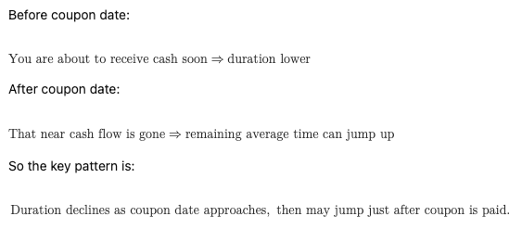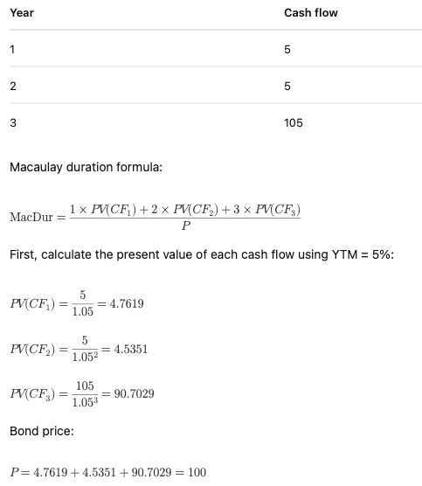

Question 21
leverage ratio=debt/capital,debt/EBITDA,cash flows/debt
coverage ratio:EBITDA/interest expesne;EBIT/interest expense
profitability ratio

Question 22
- Commercial paper is a short-term, unsecured debt instrument issued by a company.
- backup line from bank
- In the U.S., commercial paper typically has maturities ranging from a few days up to 270 days.
- no pledge collateral
- A bill(treasury bills/t-bills) is a short-term government debt instrument.

Question 24
CDO backed by banks loans= CLO;
CDO backed by company and emerging market= CBO(Collateral Bond Obligation)
CDO backed by ABS,RMBS,CMBS,other CDOs are structured finance CDOs

Question 27
Modified Duration:yield duration static()
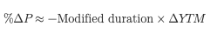
Effective Duration:price sensitivity to a parallel shift in the benchmark yield curve
Macaulay Duration:timing of cash flow not price sensitivity towards yield curve shift

Question 28
Eurobond:
- A US company issues a bond in Japanese yen outside Japan
- outside any single country’s domestic jurisdiction, or outside the jurisdiction of the currency country.
Question 33
A.bond with embedded option: don’t have well-defined internal rate of return(yield-to-maturity);modified and Macaulay durations don’t apply;effective duration is appropriate

Ethics

Derivatives

Alternatives

Financial Statement

Portfolio Management

Equity Investment

Quant

Economics

Corporate Finance

CFA Mock

Mock 1

Mock 2

Mock 3

Mock 4

Mock 5

Random Discuss

- why net income is different from cash flow,isn’t it just the cash-in and cash-out?
- Anti-risk asset
  - safe haven currecies
    - Japanese yuan:net creditor
- subtypes of derivates
- risk management and profit generation

